COVID-19 Relationship to Hospital Locations
Graduate/Undergraduate Group 3B
Austin Joseph, ajosep24@kent.edu
Brody Peelman, bpeelman@kent.edu
Anna Prack aprack@kent.edu
Matthew Miller mmill224@kent.edu
1. Introduction
- Motivation examples of this project
When COVID-19 first spread there were serious effects to people, businesses, and families. So much so that COVID was the cause of 1 out of every 8 deaths in the US in 2020 and making it the third leading cause of death [1]. Many hospitals were overwhelmed and even today COVID is still very prevalent.
- Real applications
Our goal for this project is to collect info about how many cases of COVID there were in an area in comparison to the amount of hospitals in those areas in order to allow that information to be used by others for multiple purposes. For example, seeing if cases were more common with more hospitals around or to maybe compare this information to areas where deaths from COVID occur to see if there is a correlation with the available hospitals.
2. Project Description
- Brief descriptions of your project
This project seeks to analyze the relationship between COVID-19 infection rates and proximity to a hospital. This project will combine data sets with information on the date and location of COVID-19 cases with data of the location of hospitals. We will then analyze this data for further insight in this relationship.
- Challenges and technical contributions (new problems or new solutions?) in your project
We may have issues with integrating the COVID-19 infection and hospital data sets, as they may be formatted differently or have different levels of granularity. We may also have issues with data being missing. It will be important to clean and preprocess the data.
However, this project would contribute a combined data set that could give insight into the relationship between the proximity to hospitals and the impact of a pandemic.

- The workload distribution for each member in your team
  - Austin will work on cleaning the data
  - Brody will work on sample statistic generation
  - Anna will work on testing the hypothesis
  - Matt will work on summarizing the report and visual applications
3. Background
• Related papers (or surveys)
- https://qualitysafety.bmj.com/content/31/1/45.abstract
- https://www.sciencedirect.com/science/article/pii/S1477893921000454
- https://shmpublications.onlinelibrary.wiley.com/doi/abs/10.12788/jhm.3539
• Software tools (DBMS, GUI, IDE, existing library, ...)
- Python development in a coding environment, i.e. VS Code
- Libraries such as:
  - Pandas
  - Geopandas
  - Matplot
• Required hardware
- Computer machine that supports the use of a higher-level dataset.
• Related programming skills (functions, Internet programming, object-oriented programming, distributed environment, etc.)
- Python programming/development
- Data-manipulation functions
- Environment handling with computing services
- Data analysis in visualization modeling

4. Problem Definition
Our null and alternative hypotheses:
H₀: There is no relationship between COVID-19 infection count and county hospital density.
H₁: There is a relationship between COVID-19 infection count and county hospital density.
We will use the standard 95% confidence interval, failing to reject the null hypothesis if the sample mean falls within the 95% confidence interval, and accepting the alternative hypothesis if the sample mean falls outside of the 95% confidence interval. We will introduce a variable called hospital density, which is equal to the number of hospitals per county.
Some challenges we may face in answering these questions will include using two very distinct sets of data that are formatted differently, dealing with missing data, and controlling for the correct factors. We may find that we need to exclude certain parts of the year or sectors of the country in order to extract meaningful information. Additionally, the location data for the COVID-19 infection dataset is imprecise, as it is aggregated by date and locale. This may render our question unanswerable using the data we have collected.
We will use python to join our datasets and create our sample statistics, then we will determine the standard error to set our confidence interval, and from there determine whether the sample mean falls within the 95% confidence interval of the population mean.
5. The Proposed Techniques (Brody, Austin, Anna)
• Framework (problem settings)
Problem Overview:
In this project we hope to visualize data in different ways with COVID-19 data and hospital data to make easy to digest information related to them more available for others to use and reference.
Steps in Framework:
Acquire Data:
Acquire the data by creating a variable for the wanted columns in each dataset that is needed for the intended graph.
Preprocess Data:
Heatmaps - Convert strings of all counties and states to lowercase letters for consistency. Map the state codes to names.
Merge Data:
Cases per county heatmap - Left join the geographic data and COVID case data.
Cases per hospital - Left join is also used here but for the hospital and COVID case data.
Process Data:
Cases per hospital - Divide the cases per county by the hospitals per county and apply a logarithmic transformation on the data to prevent a skew.
Visualize Data:
Heatmap - Create a choropleth of the number of COVID-19 cases by county.
• Details of major techniques (e.g., pruning methods in lemmas/theorems; illustrated with toy
examples)
Left join is used to do a type of pruning that only adds data where there is matching (state, county) in cases_df as counties_df.

Data Preprocessing:
- Tuples missing data: When manipulating the COVID-19 Dataset for final case counts, some counties did not contain data for this field. The median was calculated for the total counts and used in place.
- Normalization for color scaling: Because the total cases variable showed heavy skewness (Most tuples were less than fifty thousand, but had large outliers like four-hundred thousand), the ‘vmax’ parameter needed adjustment. The ‘vmax’ details the maximum value of our color scale. A heavily skewed value was chosen which allowed for better visualization disparity.
Construction Technique:
- The color intensity of each county describes their total case count. With a deeper, darker shade the county is represented to have had a more severe outbreak. Lighter counties showed lesser numbers of cases.
Example:
- ‘Vmax’ variable determines the scaling of the color gradation.
- The darker the county shades, the higher the total case count.

• Encoding or indexing of data
- Geopandas is used for geospatial indexing and builds spatial indexes with libraries. Pandas indexing is also used and it uses a row index.
- Join Key encoding is done for merging when we want to compare “state” + “county”, they are made lowercase so they are uniform.
• Query processing algorithms (pseudo code) and query optimization
Data Preprocessing (Into Total):
- Pseudo Code:
- Input raw dataset with parameters of ‘’state’, ‘county’, and ‘cases’
- Load into DataFrame using pandas
- Group by ‘state’ and ‘county’:
  - Locate the final entry of ‘cases’ for each ‘state, county’ pair
- Rename ‘cases’ to ‘total_cases’
- Output into .csv file, in descending order
- Optimizations:
  - Grouping: Groups upon ‘state’ and ‘county’ to avoid ambiguity between same name counties in different states.

Data Preprocessing (Into Graph Processing):
- Pseudo Code:
- Input raw dataset with parameters of ‘state’, ‘county’, and ‘total_cases’
- Load into DataFrame using pandas
- Handle missing values:
  - Calculate median of ‘total_cases’. Use in place for tuples with this missing variable.
- Standardize tuples to lowercase, like ‘state’
- Group data:
  - Using a dataset containing each county's state FIPS code and latitude/longitude coordinates, join this with the cases dataset. Allows to determine the county's position on the map graph.
  - Merge on ‘state’, ‘county’ by left join.
- Reshape into pivot table:
- Normalize color scaling using ‘vmax’
- Output DataFrame to be processed into heatmap
- Optimizations:
  - Map tuning: Adjusting the ‘vmax’ variable tunes how the map is scaled in color.
  - Data cleaning: Converting all tuple values into lowercase strings supports consistency and avoids error in merging.
Geospatial Visualization:
- Pseudo Code:
- Input cases dataset and US county shapefile with geometries
- Load shapefile into geopandas, cases dataset into pandas
- Create the heat map:
Color counties map based on ‘total_cases’ count
  - Gradient used in measuring severity
  - Set ‘vmax’ limit
- Format title and graph styles
- Output choropleth graph that details the case counts by county in the U.S
- Optimizations:
  - Map tuning: Like as above, the ‘vmax’ scaling variable determines the overall distribution the graph will show.

6. Visual Applications
Our code does not produce a GUI, but instead evaluates the data for the purposes of hypothesis testing and visual graph generation. These graphs have been used to help us visualize the data in order to help us form a hypothesis and decide which attributes are worth considering.
Here are the graphs we generated to help us visualize the data:
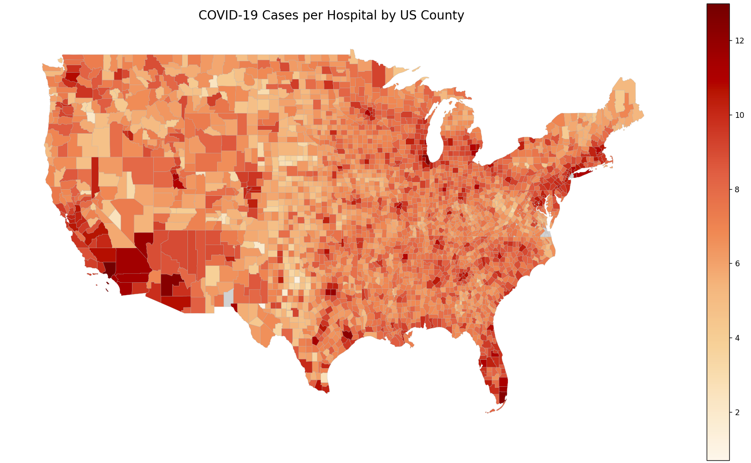
This graph shows every county in the contiguous U.S. Each county’s color is based on the number of COVID-19 cases in that county divided by the number of hospitals in that county. Those with a higher result are colored more red. This helped us determine that there are some places that have significant differences in this ratio.
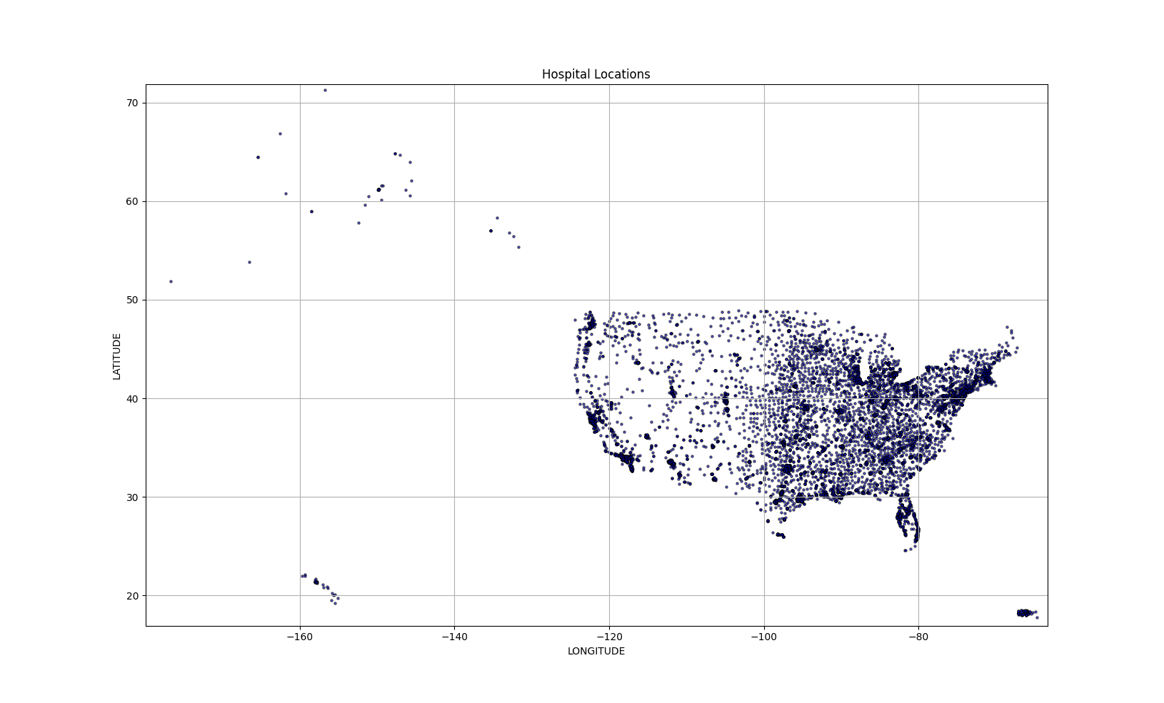
Each dot in this graph represents the location of a hospital in the United States. This visualization helped us see where hospitals were concentrated most. Referring to this graph in addition to the COVID-19 Cases Per Hospital by U.S. Country heatmap helped us visualize a relationship between hospital locations and concentration of COVID-19 cases.
7. Experimental Evaluation
The raw hospital data we used to generate these graphs came from a publicly available arcgis repository. This data has many attributes, including a precise longitude and latitude coordinate pair, in addition to relative location data (like county and state). There are dozens of columns that we did not need to use for this project, like links to the hospital websites, number of staff, and the name of the hospital. Every hospital in the United States should be represented.
Similarly, the COVID-19 data is publicly available. Each record in this database represents one day in one county. It covers January 21, 2020 to December 4, 2020 in every county in the United States. Each record has the following attributes: date; county; state; fips (a county identifier), total cumulative COVID-19 cases as of the date of record; and deaths related to COVID-19. The days before January 21 are not covered because there were no known COVID-19 cases in the United States before that date. Similarly, some counties do not have records for every single date represented in the database. This is the case for a county and date combination if there were no deaths related to COVID-19 and no total cumulative cases of COVID-19 for a county. We used this dataset to determine the total number of COVID-19 cases per county, and saved that as a separate dataset, along with the fips county identifier.
From these data sets, we generated additional attributes, such as cases per hospital for each county.

Hypothesis Testing
Here, we demonstrate the hypothesis testing process and results, for which we used R:
Read the hospital data:
hospital_data <- read_csv("data/Hospitals_gdb_771050112109123987.csv")
## Rows: 8340 Columns: 34
## ── Column specification ────────────────────────────────────────────────────────
## Delimiter: ","
## chr (25): ID, NAME, ADDRESS, CITY, STATE, ZIP, ZIP4, TELEPHONE, TYPE, STATUS...
## dbl (9): OBJECTID, POPULATION, LATITUDE, LONGITUDE, NAICS_CODE, TTL_STAFF, ...

Read the COVID-19 data:
covid_data <- read_csv("data/total_cases_by_county.csv")
## Rows: 3217 Columns: 4
## ── Column specification ────────────────────────────────────────────────────────
## Delimiter: ","
## chr (2): state, COUNTY
## dbl (2): COUNTYFIPS, total_cases

Preprocess hospital data and COVID-19 data, ensuring the join column is the same data type:
hospital_density <- hospital_data %>%
count(COUNTYFIPS, name = "hospital_count")
covid_data <- covid_data %>%
mutate(COUNTYFIPS = as.character(COUNTYFIPS))
hospital_density <- hospital_density %>%
mutate(COUNTYFIPS = as.character(COUNTYFIPS))

Join by county (using FIPS code)
combined_data <- covid_data %>%
inner_join(hospital_density, by = "COUNTYFIPS")

Visualize the data:
ggplot(combined_data, aes(x = hospital_count, y = total_cases)) +
geom_point() +
geom_smooth(method = "lm", se = TRUE) +
labs(title = "COVID-19 Cases vs Hospital Density",
x = "Hospitals per County",
y = "Total COVID-19 Cases")
## `geom_smooth()` using formula = 'y ~ x'
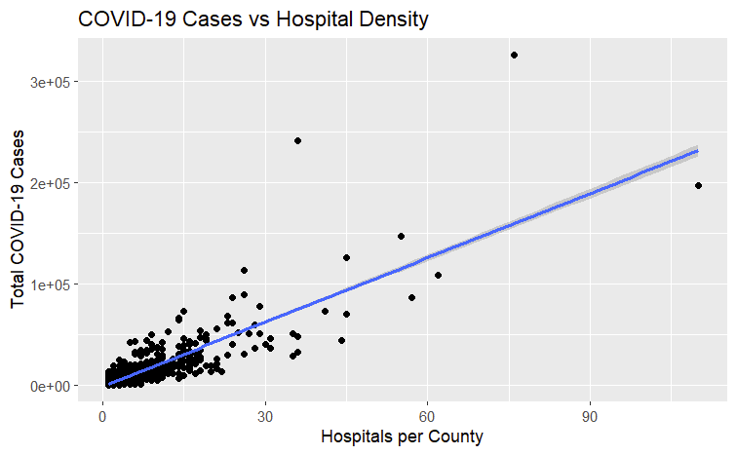

Test hypothesis:
model <- lm(total_cases ~ hospital_count, data = combined_data)
summary(model)
##
## Call:
## lm(formula = total_cases ~ hospital_count, data = combined_data)
##
## Residuals:
## Min 1Q Median 3Q Max
## -47729 -1047 -94 913 166560
##
## Coefficients:
## Estimate Std. Error t value Pr(>|t|)
## (Intercept) -1392.9 171.2 -8.139 6.46e-16 ***
## hospital_count 2113.8 27.5 76.872 < 2e-16 ***
## ---
## Signif. codes: 0 '***' 0.001 '**' 0.01 '*' 0.05 '.' 0.1 ' ' 1
##
## Residual standard error: 7244 on 2318 degrees of freedom
## Multiple R-squared: 0.7183, Adjusted R-squared: 0.7181
## F-statistic: 5909 on 1 and 2318 DF, p-value: < 2.2e-16
confint(model)
## 2.5 % 97.5 %
## (Intercept) -1728.561 -1057.303
## hospital_count 2059.846 2167.690

This p-value of less than 2.2e-16 falls outside of our confidence interval of 2.5-97.5%, indicating that we should reject the null hypothesis and accept the alternative hypothesis. That is, the data indicates a relationship between hospital count and total number of COVID-19 cases in United States counties in 2020, with a model fit of 71.8%, which indicates a very strong relationship between the two variables. Finally, our 95% confidence interval is 2059.846 to 2167.69, indicating that the actual coefficient of COVID-19 cases per hospital is positive, meaning that there is likely a positive relationship between hospital count and COVID-19 cases for United States counties in 2020.
o Parameter settings
Pertaining to the covid cases, we considered:
- State
- County
Pertaining to Hospitals, we considered:
- Latitude (Hospital Location graph)
- Longitude (Hospital Location graph)
- State
- County
We also considered the covid cases per hospital
o Evaluation measures
• The performance report (pruning power, recall/precision/f-measure, CPU time, I/O cost,
communication cost, index construction time/space, etc.)
Hospital Locations:
- Memory used ~ 0.13 MB
- Runtime ~ 0.20 seconds
Cases per county:
- Memory used ~ 1.62 MB
- Runtime ~ 0.41 seconds
Cases per hospital per county:
- Memory used ~ 1.70 MB
- Runtime ~ 0.42 seconds

8. Future Work
While we were able to visualize information pretty well, there is still more that can be looked at. Some possibilities for extensions on this are adding the population of the counties as a factor to possibly compare, finding the political alignment for each county, and seeing if that is a factor, or adding interactivity with the graphs to better visualize the information for each county. Also, others can use these graphs and visualizations for other possible projects and research.

9. References
[1] U.S. Department of Health and Human Services. (2022, August 3). Covid-19 was third leading cause of death in the United States in both 2020 and 2021. National Institutes of Health. https://www.nih.gov/news-events/news-releases/covid-19-was-third-leading-cause-death-united-states-both-2020-2021

